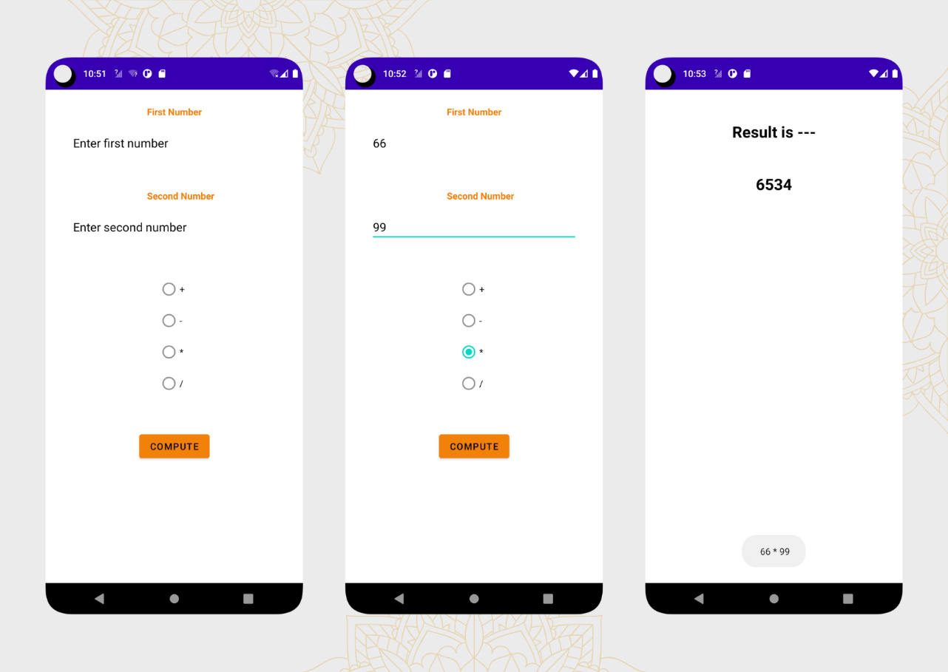

First kotlin file

package alpha.dex.dex_five

import android.content.Intent

import androidx.appcompat.app.AppCompatActivity

import android.os.Bundle

import android.widget.Button

import android.widget.EditText

import android.widget.RadioButton

import android.widget.RadioGroup

class MainActivity : AppCompatActivity() {

override fun onCreate(savedInstanceState: Bundle?) {

super.onCreate(savedInstanceState)

setContentView(R.layout.activity_main)

val b1 = findViewById<Button>(R.id.button)

val rg1 = findViewById<RadioGroup>(R.id.radioGroup)

val rb = arrayOfNulls<RadioButton>(4)

val et1 = findViewById<EditText>(R.id.editText2)

val et2 = findViewById<EditText>(R.id.editText3)

rb[0] = findViewById(R.id.radioButton)

rb[1] = findViewById(R.id.radioButton2)

rb[2] = findViewById(R.id.radioButton3)

rb[3] = findViewById(R.id.radioButton4)

b1.setOnClickListener {

val i = Intent(this, MainActivity2::class.java)

val b = Bundle()

val x: Int = et1.text.toString().toInt()

val y: Int = et2.text.toString().toInt()

when (rg1.checkedRadioButtonId) {

R.id.radioButton -> {

b.putString("operation", "+")

}

R.id.radioButton2 -> {

b.putString("operation", "-")

}

R.id.radioButton3 -> {

b.putString("operation", "*")

}

R.id.radioButton4 -> {

b.putString("operation", "/")

}

}

//Toast.makeText(MainActivity.this," hh"+b.getString("operation"),Toast.LENGTH_LONG).show();

b.putInt("First", x)

b.putInt("second", y)

i.putExtra("info", b)

startActivity(i)

}

}

}

**First xml file**

**<?xml version="1.0" encoding="utf-8"?>**

**<androidx.constraintlayout.widget.ConstraintLayout xmlns:android="http://schemas.android.com/apk/res/android"**

**xmlns:app="http://schemas.android.com/apk/res-auto"**

**xmlns:tools="http://schemas.android.com/tools"**

**android:layout_width="match_parent"**

**android:layout_height="match_parent"**

**android:background="@color/white"**

**tools:context=".MainActivity">**

**<TextView**

**android:id="@+id/textView"**

**android:layout_width="wrap_content"**

**android:layout_height="wrap_content"**

**android:layout_marginTop="24dp"**

**android:text="First Number"**

**android:textColor="#F2810A"**

**android:textStyle="bold"**

**app:layout_constraintBottom_toTopOf="@+id/editText2"**

**app:layout_constraintEnd_toEndOf="parent"**

**app:layout_constraintStart_toStartOf="parent"**

**app:layout_constraintTop_toTopOf="parent" />**

**<EditText**

**android:id="@+id/editText2"**

**android:layout_width="wrap_content"**

**android:layout_height="wrap_content"**

**android:layout_marginTop="16dp"**

**android:ems="15"**

**android:textColor="@color/black"**

**android:textColorHint="@color/black"**

**android:hint="Enter first number"**

**android:inputType="numberDecimal"**

**app:layout_constraintEnd_toEndOf="parent"**

**app:layout_constraintStart_toStartOf="parent"**

**app:layout_constraintTop_toBottomOf="@+id/textView"/>**

**<TextView**

**android:id="@+id/textView2"**

**android:layout_width="wrap_content"**

**android:layout_height="wrap_content"**

**android:layout_marginTop="48dp"**

**android:text="Second Number"**

**android:textStyle="bold"**

**android:textColor="#F2810A"**

**app:layout_constraintStart_toStartOf="@+id/textView"**

**app:layout_constraintTop_toBottomOf="@+id/editText2" />**

**<EditText**

**android:id="@+id/editText3"**

**android:layout_width="wrap_content"**

**android:layout_height="wrap_content"**

**android:layout_marginTop="16dp"**

**android:ems="15"**

**android:textColor="@color/black"**

**android:textColorHint="@color/black"**

**android:hint="Enter second number"**

**android:inputType="numberDecimal"**

**app:layout_constraintStart_toStartOf="@+id/editText2"**

**app:layout_constraintTop_toBottomOf="@+id/textView2"**

**app:layout_constraintVertical_bias="0.0" />**

**<RadioGroup**

**android:id="@+id/radioGroup"**

**android:layout_width="wrap_content"**

**android:layout_height="wrap_content"**

**android:layout_marginTop="48dp"**

**app:layout_constraintEnd_toEndOf="parent"**

**app:layout_constraintTop_toBottomOf="@id/editText3"**

**app:layout_constraintStart_toStartOf="parent">**

**<RadioButton**

**android:id="@+id/radioButton"**

**android:layout_width="wrap_content"**

**android:layout_height="wrap_content"**

**android:text="+"**

**android:textColorHint="@color/black"**

**android:textColor="@color/black"**

**app:layout_constraintBottom_toTopOf="@+id/radioButton2"**

**app:layout_constraintEnd_toEndOf="parent"**

**app:layout_constraintStart_toStartOf="parent"**

**app:layout_constraintTop_toBottomOf="@+id/editText3" />**

**<RadioButton**

**android:id="@+id/radioButton2"**

**android:layout_width="wrap_content"**

**android:layout_height="wrap_content"**

**android:text="-"**

**android:textColorHint="@color/black"**

**android:textColor="@color/black"**

**app:layout_constraintBottom_toTopOf="@+id/radioButton3"**

**app:layout_constraintStart_toStartOf="@+id/radioButton"**

**app:layout_constraintTop_toBottomOf="@+id/radioButton" />**

**<RadioButton**

**android:id="@+id/radioButton3"**

**android:layout_width="wrap_content"**

**android:layout_height="wrap_content"**

**android:text="*"**

**android:textColorHint="@color/black"**

**android:textColor="@color/black"**

**app:layout_constraintBottom_toTopOf="@+id/radioButton4"**

**app:layout_constraintStart_toStartOf="@+id/radioButton2"**

**app:layout_constraintTop_toBottomOf="@+id/radioButton2" />**

**<RadioButton**

**android:id="@+id/radioButton4"**

**android:layout_width="wrap_content"**

**android:layout_height="wrap_content"**

**android:text="/"**

**android:textColorHint="@color/black"**

**android:textColor="@color/black"**

**app:layout_constraintBottom_toTopOf="@+id/button"**

**app:layout_constraintStart_toStartOf="@+id/radioButton3"**

**app:layout_constraintTop_toBottomOf="@+id/radioButton3" />**

**</RadioGroup>**

**<Button**

**android:id="@+id/button"**

**android:layout_width="wrap_content"**

**android:layout_height="wrap_content"**

**android:text="compute"**

**android:backgroundTint="#F2810A"**

**android:layout_marginTop="48dp"**

**app:layout_constraintStart_toStartOf="parent"**

**app:layout_constraintTop_toBottomOf="@+id/radioGroup"**

**app:layout_constraintEnd_toEndOf="parent"/>**

**</androidx.constraintlayout.widget.ConstraintLayout>**

**Second kotlin file**

package alpha.dex.dex_five

import androidx.appcompat.app.AppCompatActivity

import android.os.Bundle

import android.widget.TextView

import android.widget.Toast

class MainActivity2 : AppCompatActivity() {

override fun onCreate(savedInstanceState: Bundle?) {

super.onCreate(savedInstanceState)

setContentView(R.layout.activity_main2)

val tv = findViewById<TextView>(R.id.textView4)

val i = intent

val b = i.getBundleExtra("info")

val x = b?.getInt("First")

val y = b?.getInt("second")

var res = 0

val op = b?.getString("operation")

Toast.makeText(this, " $x $op $y", Toast.LENGTH_LONG).show()

when (op) {

"+" -> if (x != null && y != null) {

res = x + y

}

"-" -> if (x != null && y != null) {

res = x - y

}

"*" -> if (x != null && y != null) {

res = x * y

}

"/" -> if (x != null && y != null) {

res = x / y

}

}

tv.text = res.toString()

}

}

**Second xml**

<?xml version="1.0" encoding="utf-8"?>

<androidx.constraintlayout.widget.ConstraintLayout xmlns:android="http://schemas.android.com/apk/res/android"

xmlns:app="http://schemas.android.com/apk/res-auto"

xmlns:tools="http://schemas.android.com/tools"

android:layout_width="match_parent"

android:layout_height="match_parent"

android:background="@color/white"

tools:context=".MainActivity2">

<TextView

android:id="@+id/textView3"

android:layout_width="match_parent"

android:layout_height="wrap_content"

android:text="Result is ---"

android:textColor="@color/black"

android:textStyle="bold"

android:textSize="24sp"

android:textAlignment="center"

android:layout_marginEnd="8dp"

android:layout_marginStart="8dp"

android:layout_marginTop="48dp"

app:layout_constraintStart_toStartOf="parent"

app:layout_constraintEnd_toEndOf="parent"

app:layout_constraintTop_toTopOf="parent"/>

<TextView

android:id="@+id/textView4"

android:layout_width="match_parent"

android:layout_height="wrap_content"

android:textColor="@color/black"

android:textStyle="bold"

android:textSize="24sp"

android:textAlignment="center"

android:layout_marginEnd="8dp"

android:layout_marginStart="8dp"

android:layout_marginTop="48dp"

app:layout_constraintEnd_toEndOf="parent"

app:layout_constraintStart_toStartOf="parent"

app:layout_constraintTop_toBottomOf="@+id/textView3" />

</androidx.constraintlayout.widget.ConstraintLayout>